INSTALAR POWER BI DESKTOP

https://powerbi.microsoft.com/en-au/

Products / Power BI Desktop

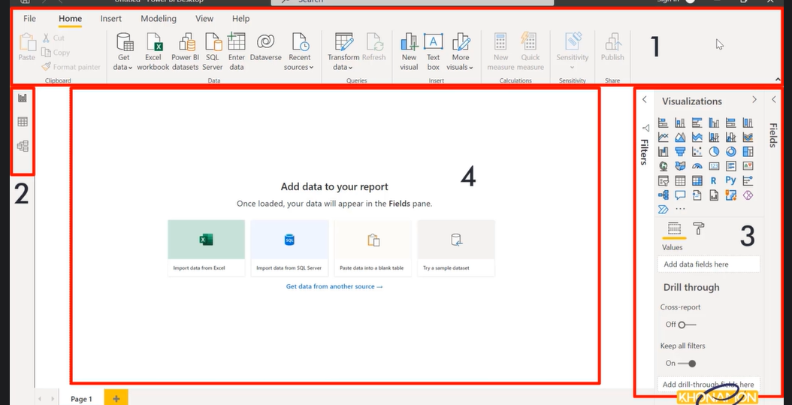

|  |  |
| --- | --- |
| Drop down from Get Data | Click icon Get Data |
|  |  |